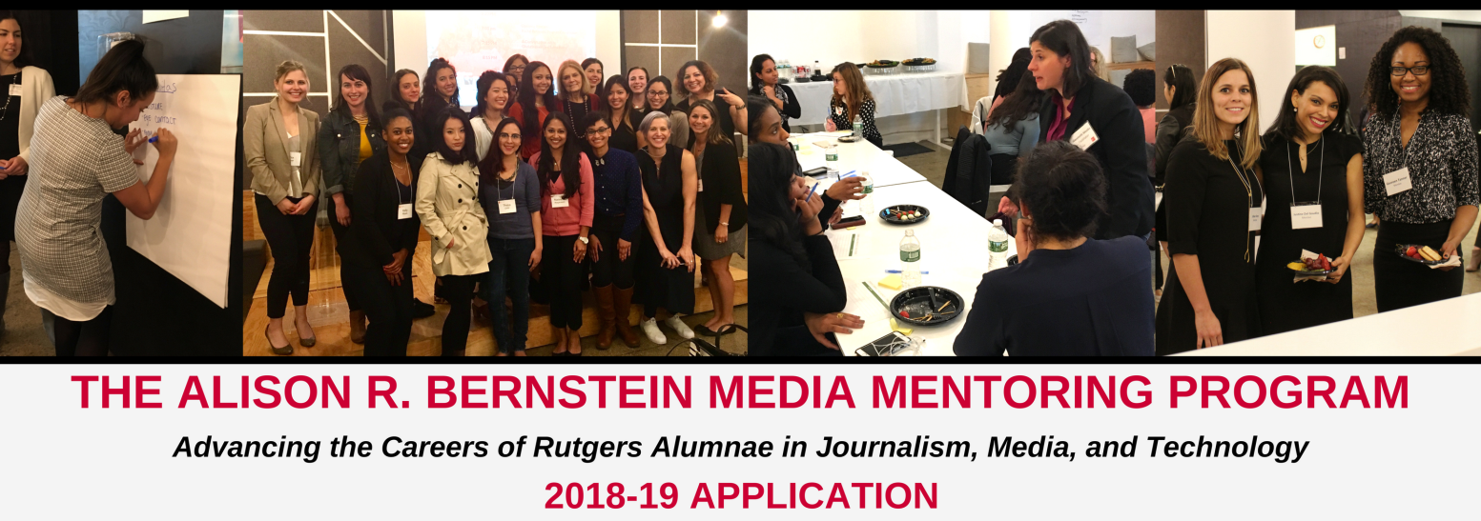

Thank you for your interest in the Alison R. Bernstein Media Mentoring Program! The Institute for Women’s Leadership (IWL) and School of Communication & Information (SCI) at Rutgers University are seeking Rutgers alumnae to be a part of this unique mentoring program. Linking recent Rutgers alumnae with accomplished women in media, technology, and journalism, the goal of this program is to enable promising women who are in the early stages of their careers to learn from experienced professionals. This partnership fosters community, encourages personal and professional growth, provides exclusive networking opportunities, and offers invaluable industry insight.

TO QUALIFY AS A MENTEE, YOU ARE:
- A Rutgers alumna who graduated 1-5 years ago
- Currently employed in the journalism, media, or information technology field
- Eager to commit and share in our mission to expanding opportunities for the next generation of women leaders and to shaping a more inclusive and just media world
*Preference given to participants who live within a 200 mile radius of New York City
AS A MENTEE, YOU ARE EXPECTED TO:
- Make initial contact with your mentor within the first week of the program
- Provide your mentor with professional development goals you hope to achieve by May 2019
- Commit to your assigned mentor by meeting for at least three in-person mentoring sessions and participate in additional monthly contact with your assigned mentor on the platform of your choice (phone, email, skype, text, etc.)
- Attend scheduled workshops and events throughout the program year (September-May)
- Communicate monthly with your mentor and the program coordinator
- Provide the program coordinator with monthly feedback on how the mentorship is developing

APPLY
To be considered as a mentee in the 2018-19 program year, please complete the three part application form on the following page. Return this application and a copy of your resume to: kylie.davidson@rutgers.edu.

PART 1:
PERSONAL INFORMATION
First Name: Click here to enter text. Last Name: Click here to enter text.

Racial/Ethnic Background: Click here to enter text.

Graduation Year: Click here to enter text.

School Graduated From: Click here to enter text.

Degree: Click here to enter text.

Street Address (Include city, state, zip): Click here to enter text.

Preferred Phone Number: Click here to enter text. Preferred Email: Click here to enter text.
Employer: Click here to enter text.
Current Title: Click here to enter text. Full Time: __ __ Part-time: __ __Hours per week: __
Part 2:
WORK EXPERIENCE
Complete your employment experience after graduation related to the Journalism/ Media/Technology
Example: NBC News Staff Writer 06/2010-08/2012
Employer Job Title Time Period (MM//YY)

- Main Responsibilities: Covered breaking news stories

- Reasons for Leaving: Left to explore new career opportunites

- Click here to enter text.
Employer Job Title Time Period (MM/YY)

- Main Responsibilities: Click here to enter text.

- Reasons for Leaving: Click here to enter text.

- Click here to enter text.
Employer Job Title Time Period (MM/YY)

- Main Responsibilities: Click here to enter text.

- Reasons for Leaving: Click here to enter text.

- Click here to enter text.
Employer Job Title Time Period (MM/YY)

- Main Responsibilities: Click here to enter text.

- Reasons for Leaving: Click here to enter text.
PART 3:
CAREER CHALLENGES AND INTEREST IN THE PROGRAM
On a scale from 1-12, 1 being the most and 12 being the least, rate the areas you need guidance in: (You need not fill out all of these)
__ __ Balance of personal/professional life
__ __ Communication skills in the work place
__ __ Coping with work culture
__ __ Concerns about bias against women
__ __ Concerns about bias against Racial Ethnicity
__ __ Gain more of a leadership role within your company
__ __ Career advancement/securing your next job
__ __ Interview skills
__ __ Establish meaningful goals
__ __ Networking/developing professional relationships
__ __ Negotiating a fair salary
__ __ Requesting pay raise
__ __ Requesting promotion
- What are the critical challenges you are currently facing or have faced while trying to secure full-time employment after graduation?

Click here to enter text.

- List three professional development or personal growth goals you wish to accomplish. Goals should be: Specific, measurable, attainable, and relevant
Goal #1: Click here to enter text.
- How your mentor can best assist: Click here to enter text.
Goal #2: Click here to enter text.
- How your mentor can best assist: Click here to enter text.
Goal #3: Click here to enter text.
- How your mentor can best assist: Click here to enter text.

- Describe the professional background and experience you would like your mentor to have:
Click here to enter text.

- What is the main feature that draws you to this program?
Click here to enter text.

- What do you hope to achieve from this mentoring program?
Click here to enter text.

- Are you looking to change directions within your career? Please explain
Click here to enter text.

- Would you be able to attend program events at Rutgers University between the hours of 6:30 pm and 8:30 pm? Please explain: Click here to enter text.

- Would you be able to attend program events in NYC between the hours of 6:30 pm and 8:30 pm?
Please explain: Click here to enter text.
The Matching Process:
The information you provide in this application will be used to find a mentor who shares similar professional, educational, and life experience background. Mentees will be notified of their acceptance into the program and their match in August 2018. Mentees are then responsible for contacting their mentors to start the process of establishing the mentoring relationship.

Mentors and mentees are expected to attend the program opening reception in September 2018 at Betaworks Studio, 29 Little West 12th Street, New York, NY. The date is TBD. Mentoring pairs who are unable to attend the opening reception are asked to establish a first-time connection in September as well. This year's program will take place from September 2018 to May 2019.

Over the course of the nine-month program, pairs are required to meet for at least three in-person mentoring sessions, however it is encouraged that pairs meet as often as possible. To ensure progress is being made, it is suggested that the first mentoring session be completed by the end of November, the second by the end of February, and the third by the end of April. Mentoring pairs are also required to engage in additional monthly contact, either by phone, text, email, skype etc. Mentees will need to complete mid-year feedback forms that will be sent to the Program Coordinator. Feedback forms allow for confidential feedback about the program and the mentoring relationship.

It is important to note that the mentors in this program are here for your benefit. Mentors expect their mentee to be engaged and committed to this mentorship.

