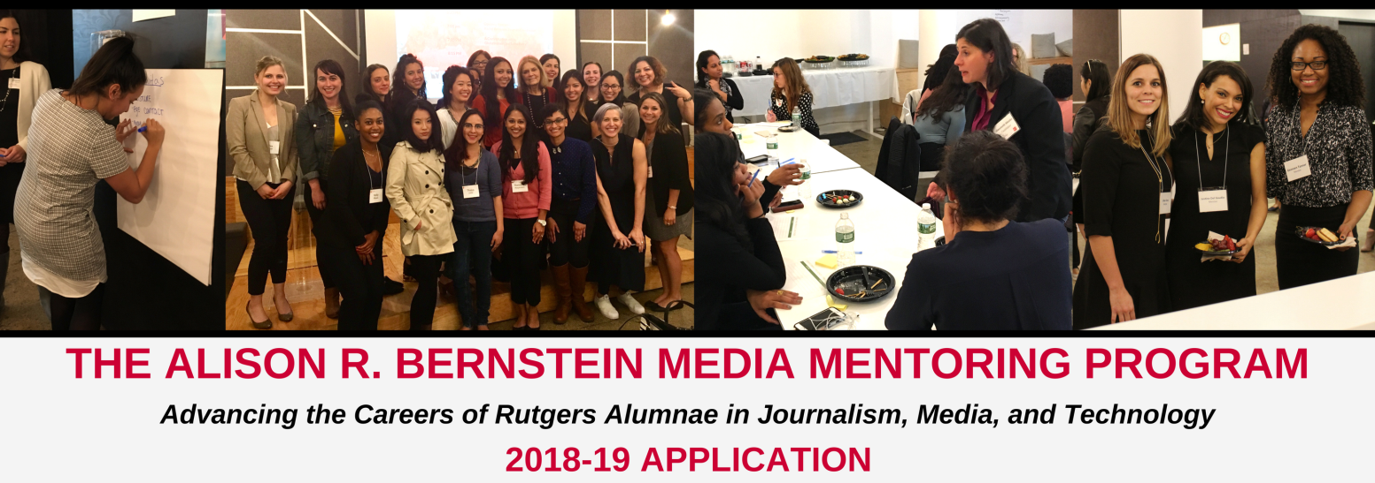

Thank you for your interest in Alison R. Bernstein Media Mentoring Program! The Institute for Women’s Leadership (IWL) and the School of Communication & Information (SCI) at Rutgers University are seeking professional women working in media, journalism, and technology to be a part of this unique mentoring program. Linking Rutgers alumnae working in media, journalism, and technology with accomplished women, the goal of this program is to enable promising women who are in the early stages of their careers to learn from experienced professionals. This partnership fosters community, encourages personal and professional growth, provides exclusive networking opportunities, and offers invaluable industry insight.

MENTORS SHOULD BE:
- Equipped with at least 7 years of professional experience in journalism, media or technology
- Prepared to guide and support a young woman in the early stages of her career
- Eager to commit and share in our mission to expanding opportunities for the next generation of women leaders and to shaping a more inclusive and just media world
AS A MENTOR, YOU CAN EXPECT:
- Your assigned mentee to contact you within the first two weeks of September
- To commit to your assigned mentee by meeting for at least three in-person mentoring sessions, participate in additional monthly contact with your assigned mentee on the platform of your choice (phone, email, skype, text, etc.), and attend scheduled special events throughout the program year (September-May)
- To provide your mentee with ongoing direction and advice as you build your mentoring relationship
- To maintain clear and frequent communication with your mentee and the program coordinator
APPLY
Apply to be a mentor for the September 2018-May 2019 program year by filling out the information on the pages below. Please return this application to: kylie.davidson@rutgers.edu.
Part 1: Contact and Personal Information
First Name: Click here to enter text. Last Name: Click here to enter text.
Racial/Ethnic Background: Click here to enter text.
Street Address (Include city, state, and zip): Click here to enter text.
Primary Phone Number: Click here to enter text.
Primary Email Address: Click here to enter text.
Part 3: Education
University: Click here to enter text.
Degree(s): Click here to enter text.
Year graduated: Click here to enter text.
Do you have previous mentoring experience? Click here to enter text.
Part 2: Professional Information
Employer: Click here to enter text. Employer Address: Click here to enter text.
Position: Click here to enter text.
How long have you been employed by this company? Click here to enter text.
Years of Related Experience: Click here to enter text.
Previous Employer: Click here to enter text.
Areas of Expertise: Click here to enter text.
Easiest way to contact you: Click here to enter text.
Would you feel comfortable having your mentee visit your office? Click here to enter text.
What do you hope to achieve by participating in this program? Click here to enter text.
What field would you like your mentee to work in? Click here to enter text.
What is the main feature that draws you to this program and what do you hope to achieve by mentoring a young woman? Click here to enter text.
Do you think your company would be interested in providing space for program workshops? Click here to enter text.

On a scale from 1-12, 1 being the most and 12 being the least, rate the areas you feel you could provide the most significant guidance in (You need not fill out all of these)

__ __ Balance of personal/professional life
__ __ Communication skills in the work place
__ __ Coping with work culture
__ __ Concerns about bias against women
__ __ Concerns about bias against racial ethnicity
__ __ Gain more of a leadership role within your company
__ __ Career advancement/securing next job
__ __ Interview skills
__ __ Establish meaningful goals
__ __ Networking/developing professional relationships
__ __ Negotiating a fair salary
__ __ Requesting pay raise
__ __ Requesting promotion
The Matching Process:
The information you provide in this application will be used to find a mentee who shares similar professional, educational, and life experience background. Mentors will be notified of their match in August 2018. Mentees are then responsible for contacting their mentor to start the process of establishing the mentoring relationship.
Mentors and mentees are expected to attend the program opening reception in September 2018 at Betaworks Studio, 29 Little West 12th Street, New York, NY. The date is TBD. Mentoring pairs who are unable to attend the opening reception are asked to establish a first-time connection in September as well. This year's program will take place from September 2018 to May 2019.
Over the course of the nine-month program, pairs are required to meet for at least three in-person mentoring sessions, however it is encouraged that pairs meet as often as possible. To ensure progress is being made, it is suggested that the first mentoring session be completed by the end of November, the second by the end of February, and the third by the end of April. Mentoring pairs are also required to engage in additional monthly contact, either by phone, text, email, skype etc.

